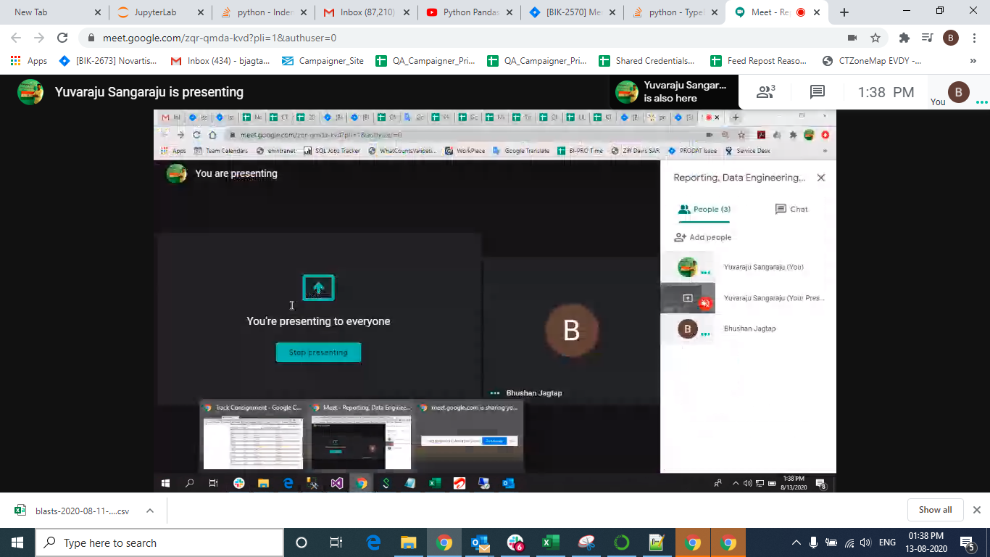

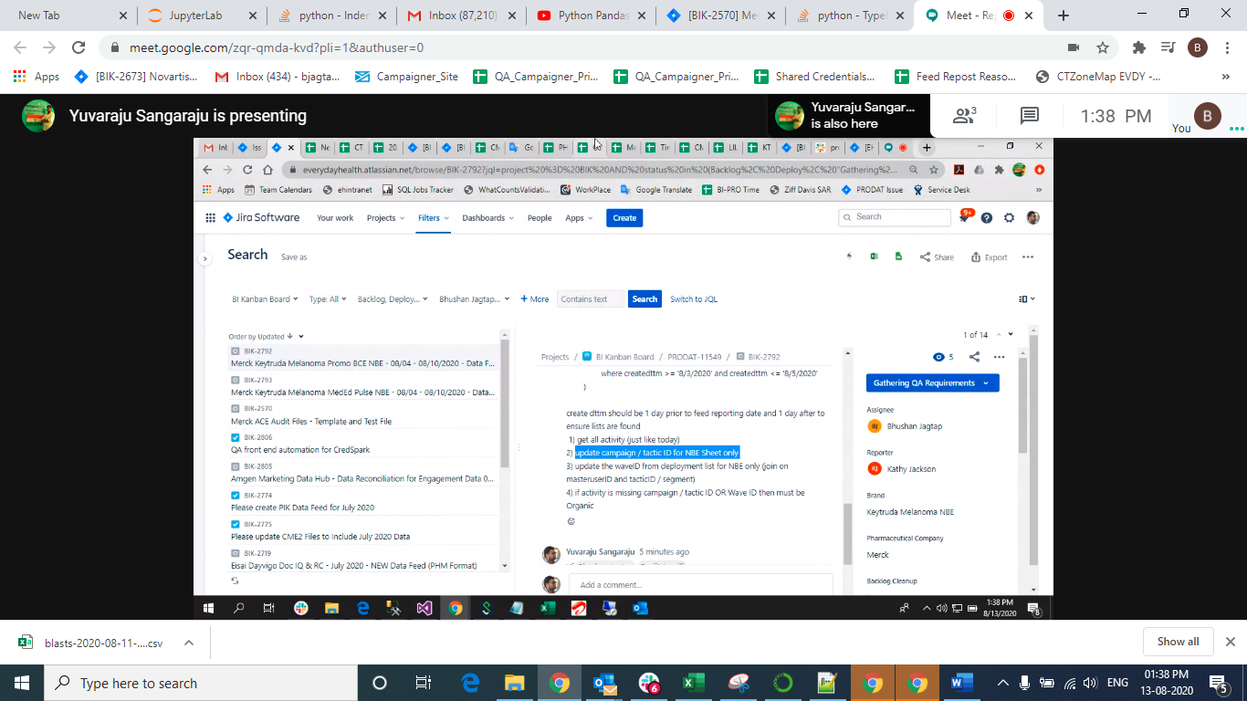

Then tactic id 1st nbve

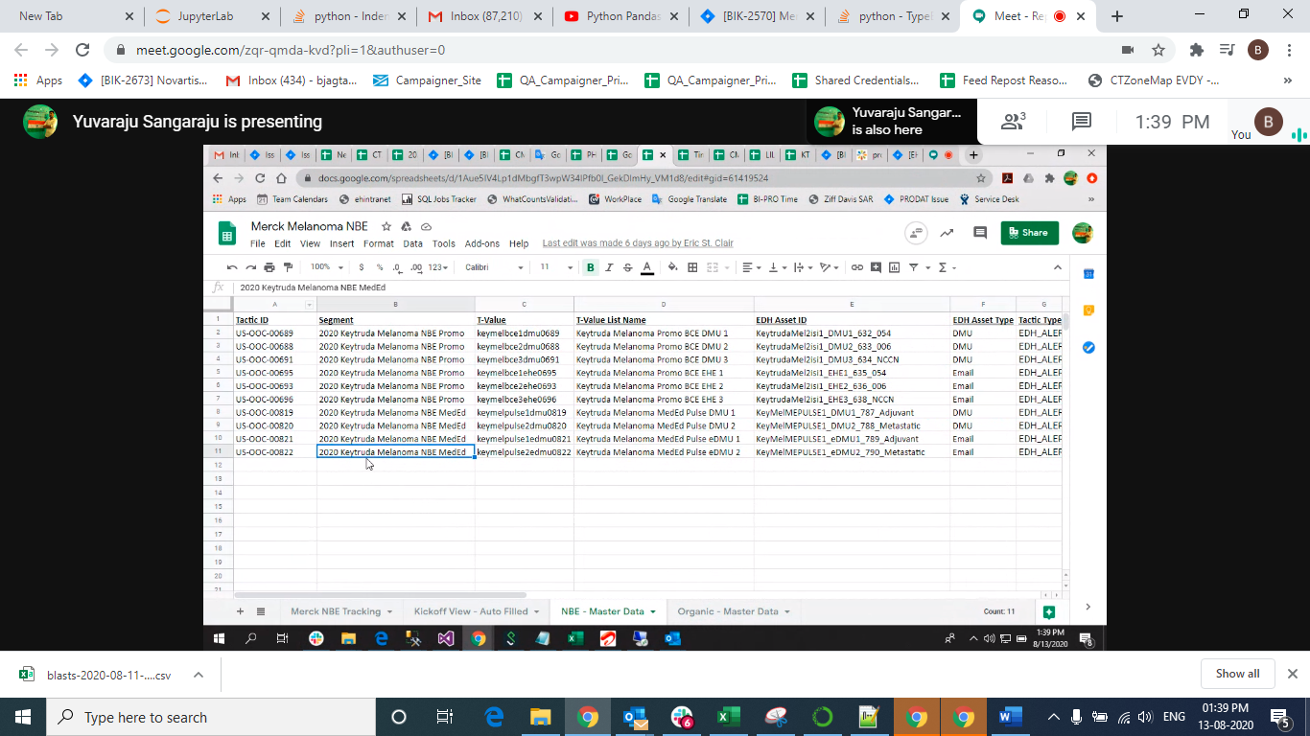

This query

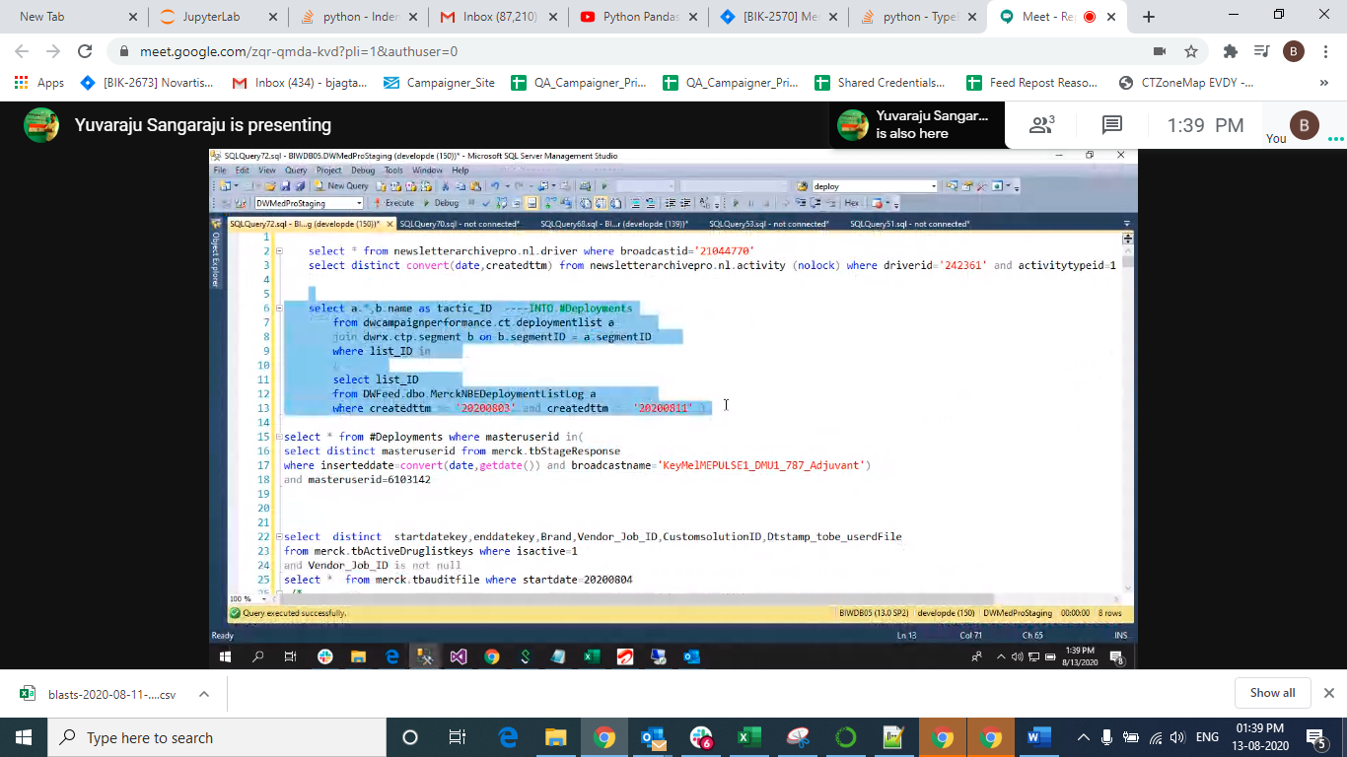

Varuablid is waveid

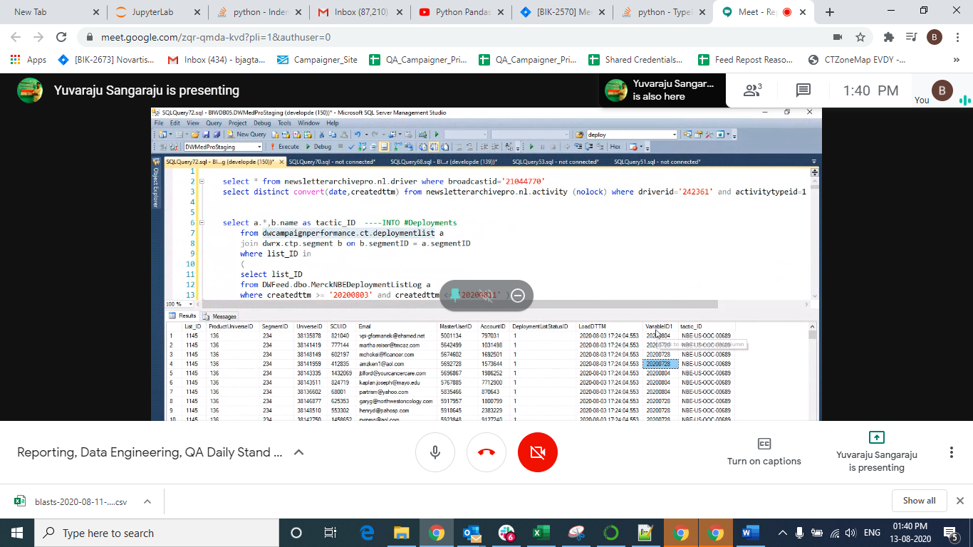

1 means organic:

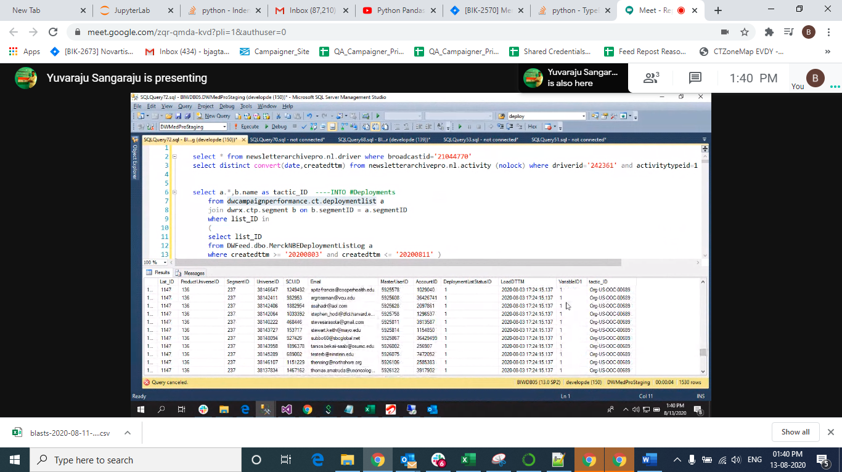

Result

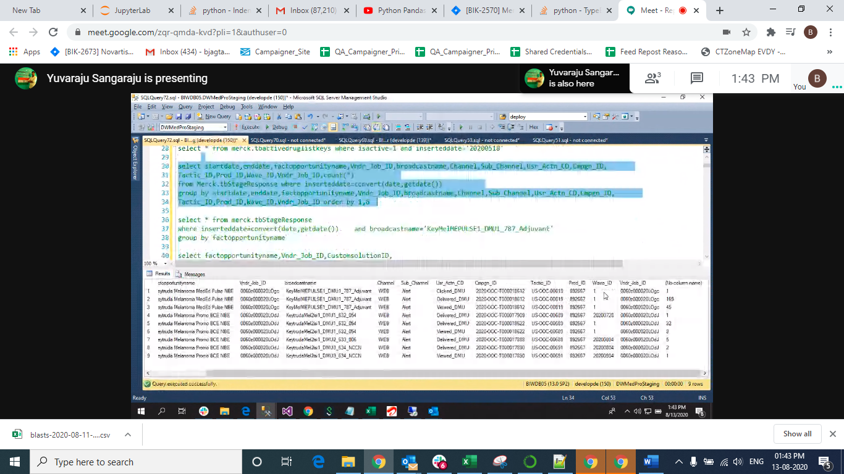

Campaign id in both then first update nbe in table

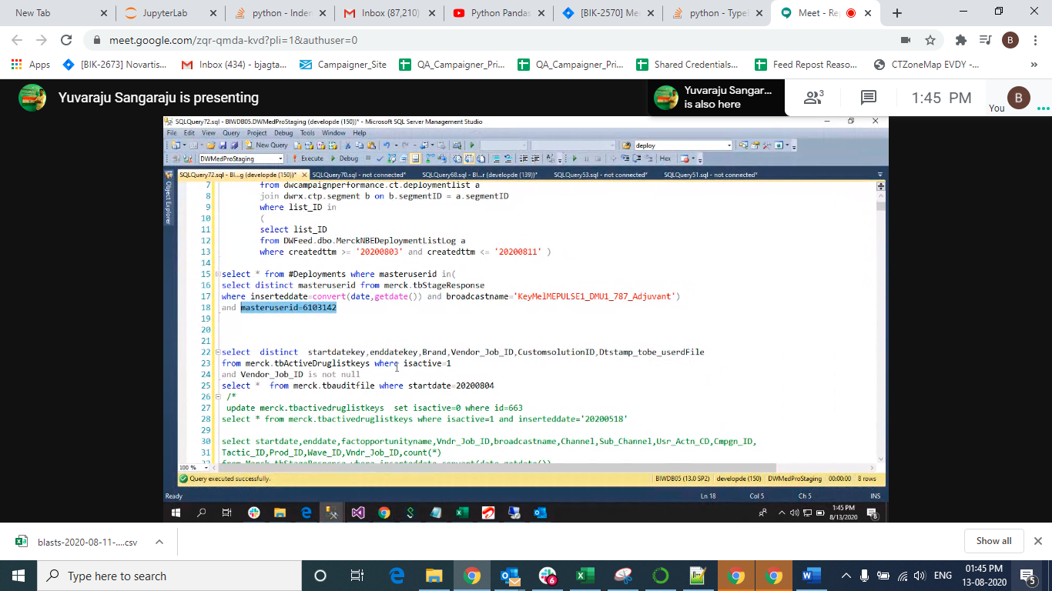

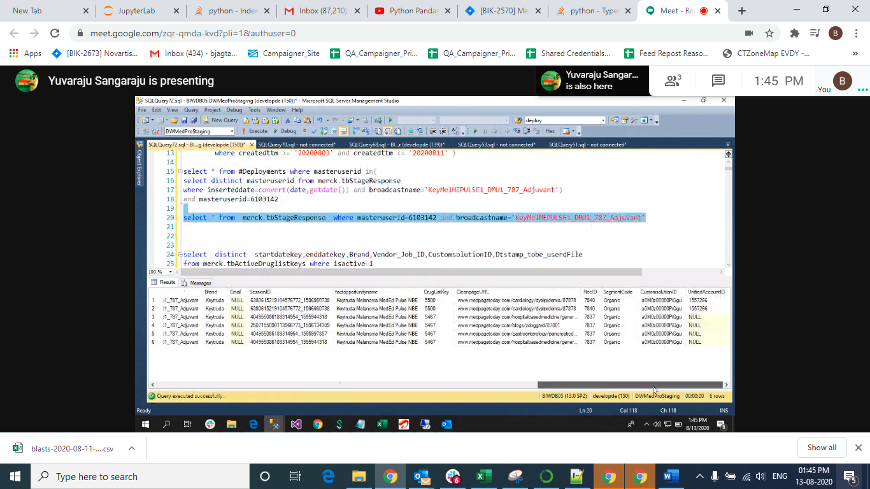

3rd point

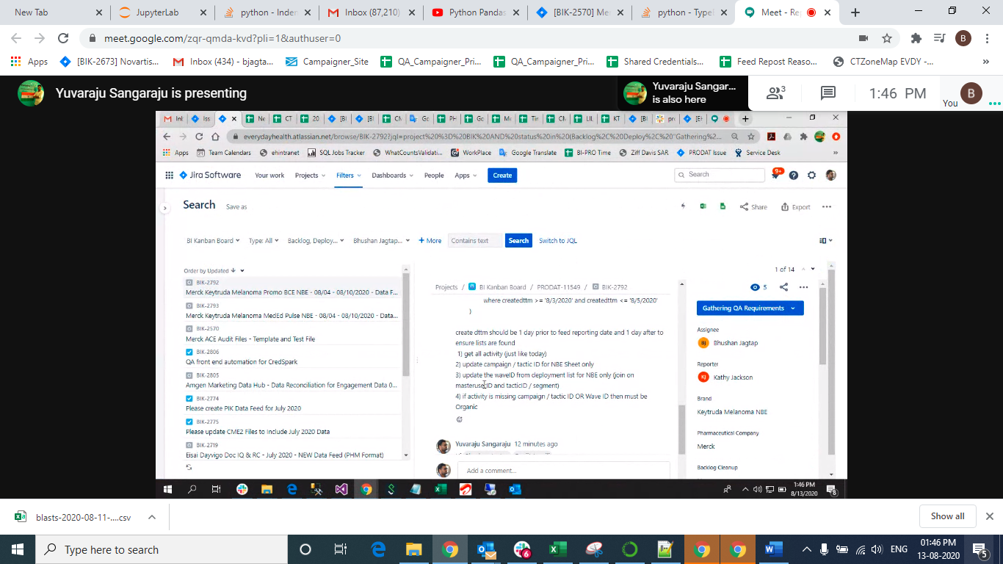

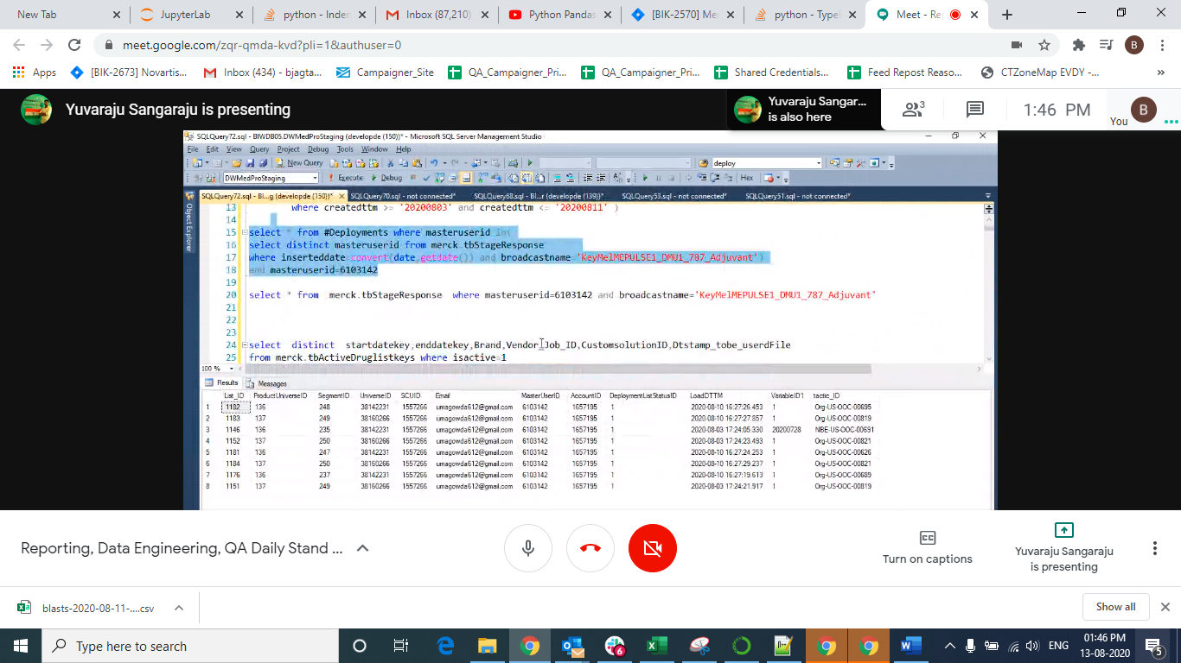

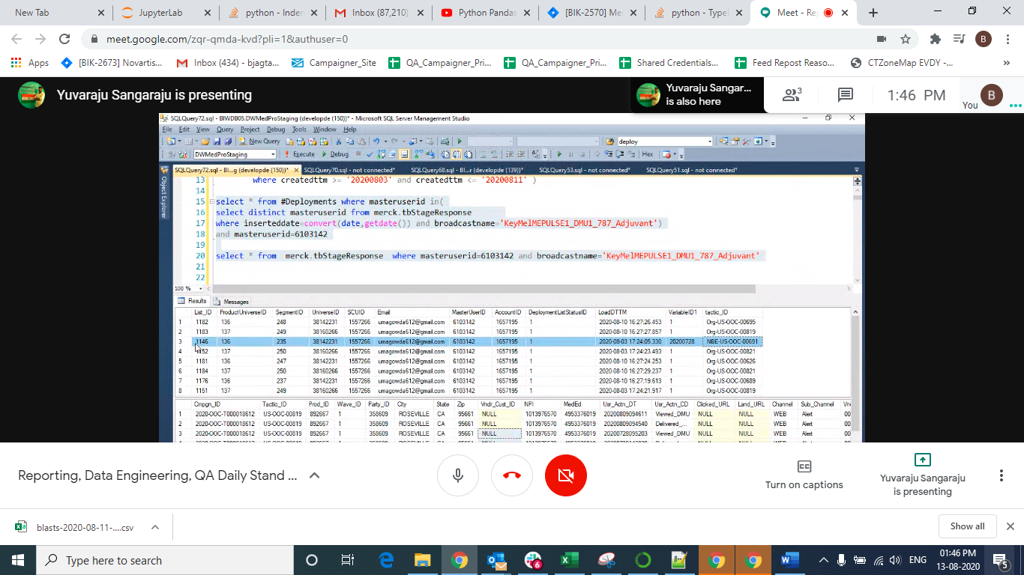

If tactic id not matche then record will be organic wave id =1 important:

==

If date is 08/04 then date filed belfor 1 day and last date log after 1 day for log table

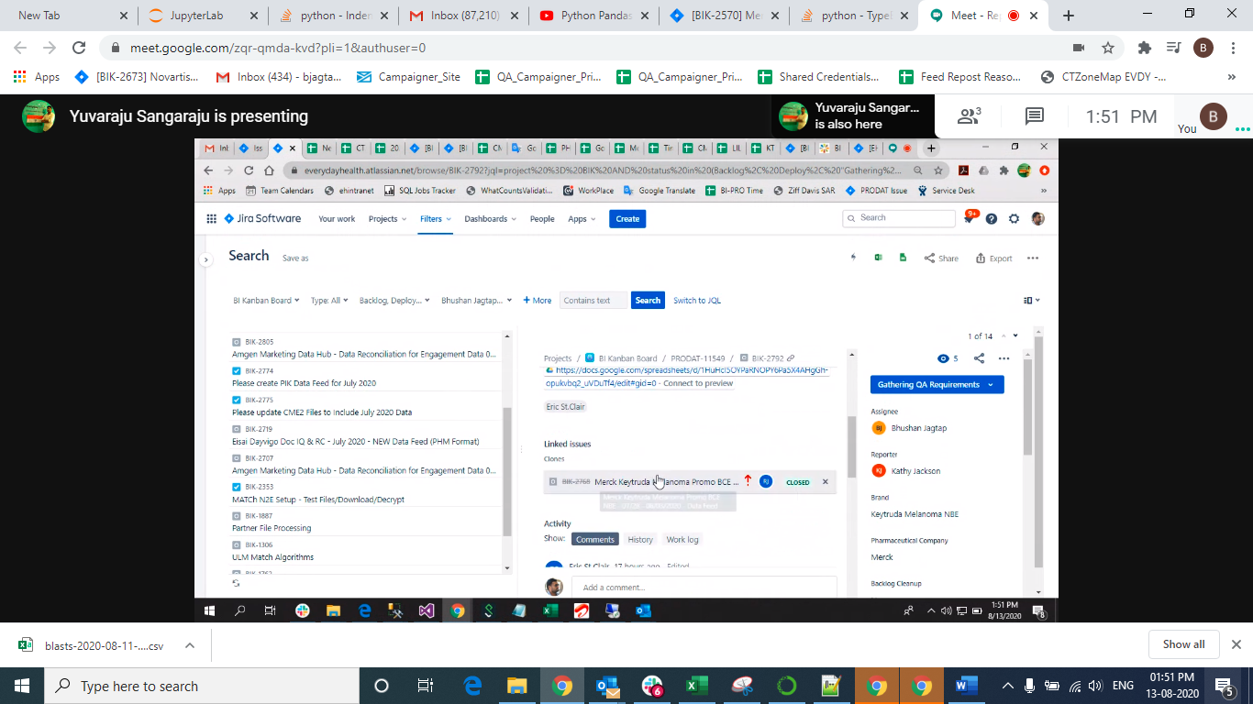

**Verification: steps**

1.st check campaign ids are available in sheet for NBE sheet and Merck sheet.

2. if both sheet have same campaign id then check tactic id is also same or not ,

If tactic id is same then update NBE first and then Organic both records in a table and update waveid as specific number like “23434”.

3.if Tactic id is not matched then record is Organic and its wave id should be ‘1’ display.S